Snake Application Guide

December 2018

Version 0.1

Document Revisions

|  |  |  |
| --- | --- | --- |
| Date | Version Number | Document Changes |
| 11/30/2018 | 0.1 | Initial Draft |
|  |  |  |
|  |  |  |
|  |  |  |
|  |  |  |
|  |  |  |
|  |  |  |
|  |  |  |
|  |  |  |

Table of Contents

1 Introduction 4

1.1 Scope and Purpose 4

1.2 Process Overview 4

2 How to Play 5

3 To End Game 6

# Introduction

## Scope and Purpose

This application allows the user to play the classic snake game. The user earns points by eating food, with the snake. The game ends when the snake touches one of the borders or the snake eats itself.

This guide will go more in-depth in explaining how the application functions during the game. It is advised that the user already have an understanding of how the classic snake works as a game, but it is not necessarily required.

## Process Overview

Upon launching the game, the game begins automatically with the snake movement being automatic also. The use controls the direction of the snake by using the four arrow keys. The left arrow key changes the direction of the snake to left or leaves it as left, the right arrow key changes the direction of the snake to right or leaves it as right, the up arrow key changes the direction of the snake to up or leaves it as up and down arrow key changes the direction of the snake to left or leaves it as down. The game ends when the snake collides with the wall or with itself (self-collision).

# How to Play

In order to use the application for its purpose, a game must first be started by the user.

1. Open the application
2. Move the snake around with the arrow keys

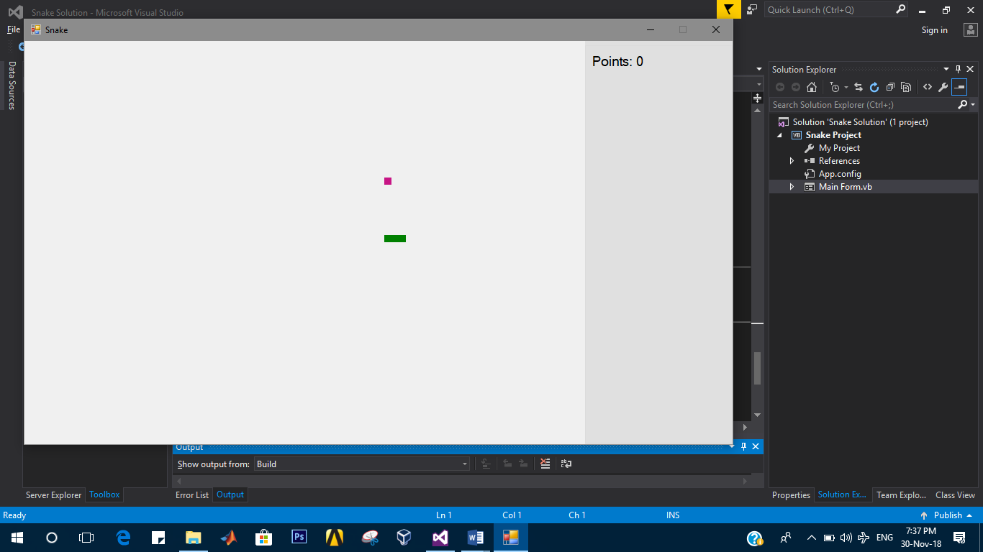

1. Eat food to earn points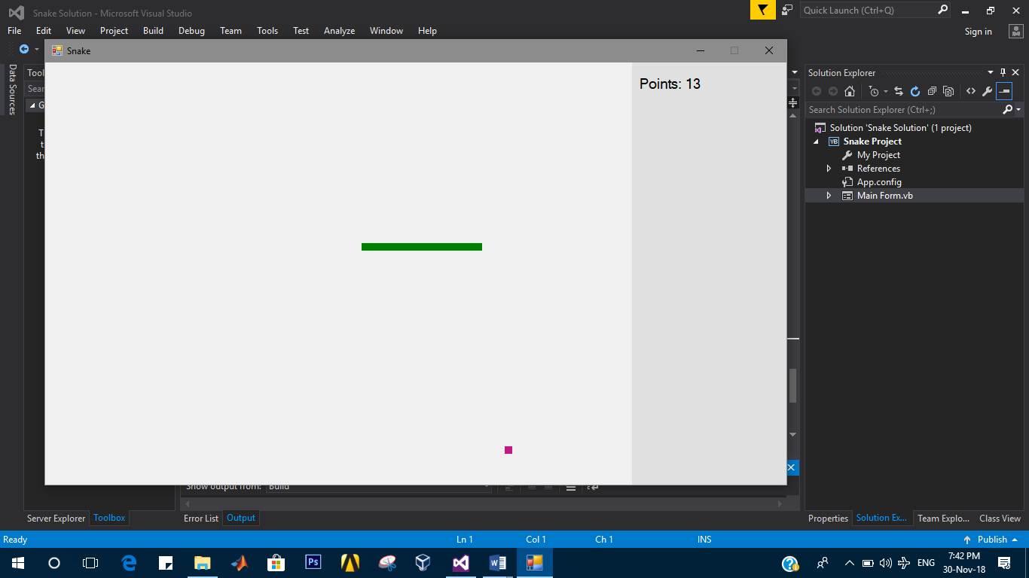

# To End Game

There are three ways to end the game:

1. Hit the border with the snake and then click OK in the message box displayed

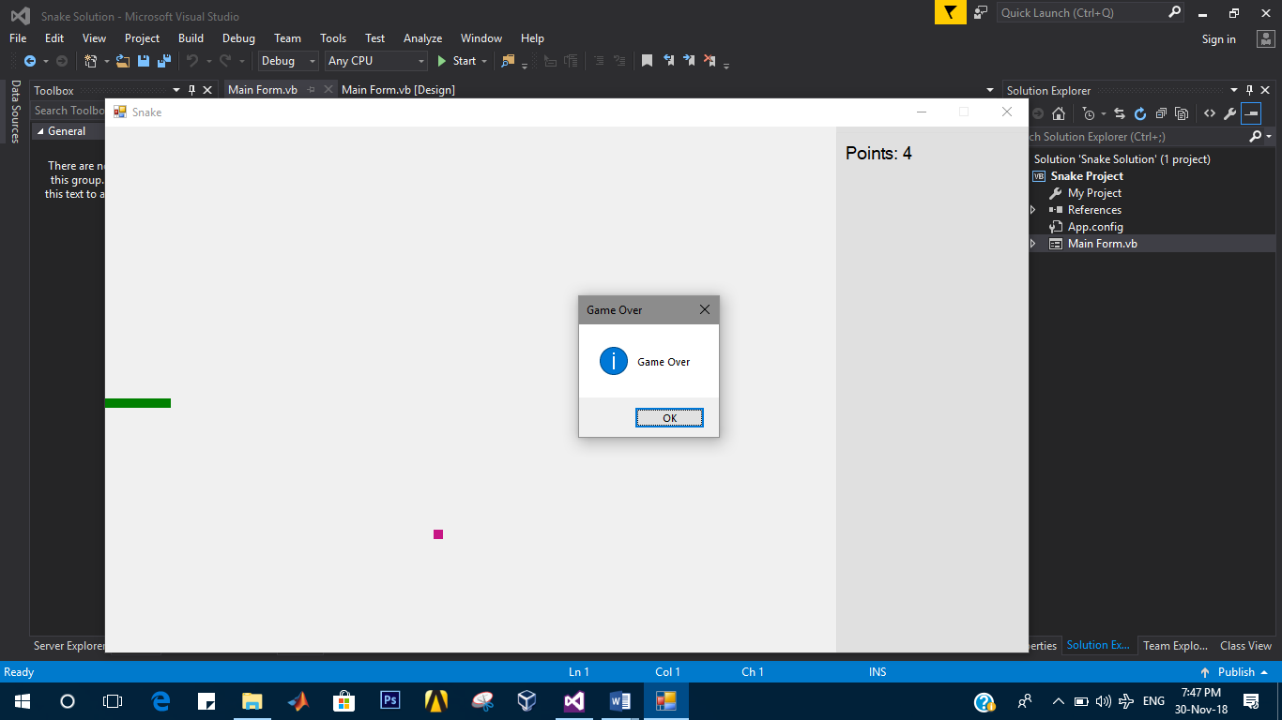

1. The snake colliding with itself and then click ok in the message box displayed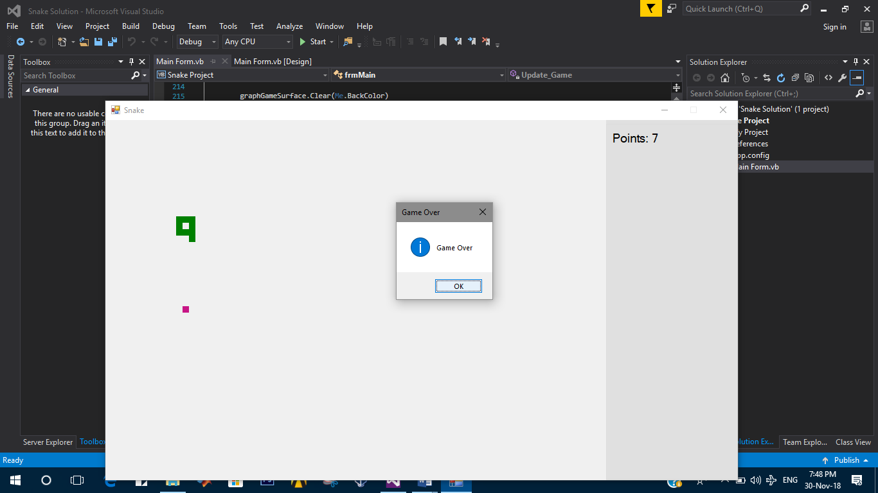
2. Press escape key on the keyboard to end the game and close the window.